**se1. Create the table SEMP with the following structure:-**

**EMPNO CHAR(4)**

**EMPNAME CHAR(20)**

**BASIC FLOAT**

**DEPTNO CHAR(2)**

**DEPTHEAD CHAR(4)**

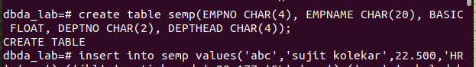

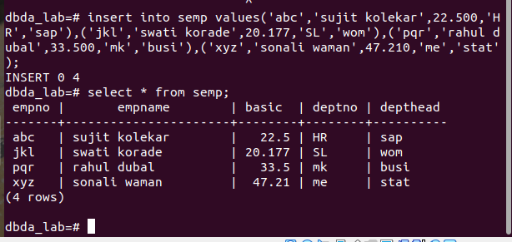

**2. Create the table SDEPT with the following structure:-**

**DEPTNO CHAR(2) DEPTNAME CHAR(15)**

**3. Insert into the SDEPT table the following values:-**

**10, Development**

**20, Training**

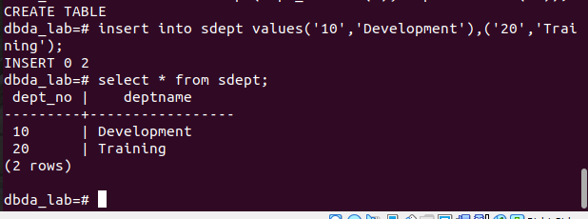

**4. Insert into the SEMP table the following values:-**

**0001, SUNIL, 6000, 10**

**0002, HIREN, 8000, 20**

**0003, ALI, 4000, 10, 0001**

**0004, GEORGE, 6000, 0002**

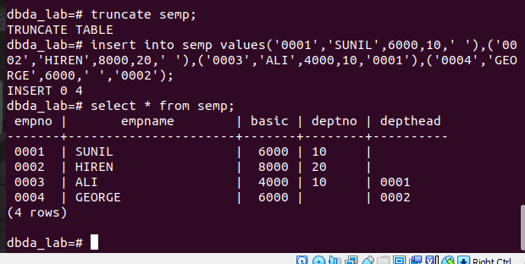

**Create S, P, J, SPJ tables as specified below and insert a few rows in each table:-**

**SUPPLIER(S#, Sname, Status, City)- S**

**PARTS(P#, Pname, Color, Weight, City)**

**- P PROJECTS(J#, Jname, City)**

**- J SUPPLIER-PARTS-PROJECT(S#, P#, J#, Qty)**

**- SPJ Sample data for S# column:- ‘S1’, ‘S2’, ‘S3’, etc.**

**Sample data for P# column:- ‘P1’, ‘P2’, ‘P3’, etc.**

**Sample data for J# column:- ‘J1’, ‘J2’, ‘J3’, etc.**

**Sample data for Status column:- 10, 20, 30, etc.**

**Write the SELECT queries to do the following:-**

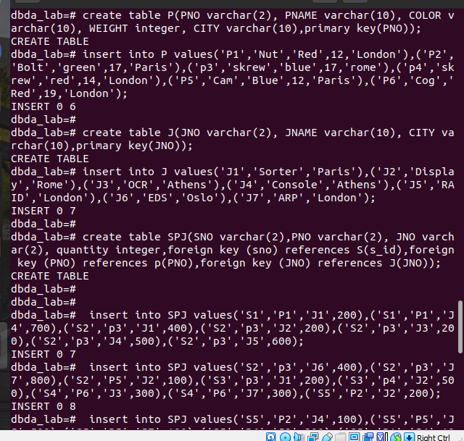

**5. Display all the data from the S table.**

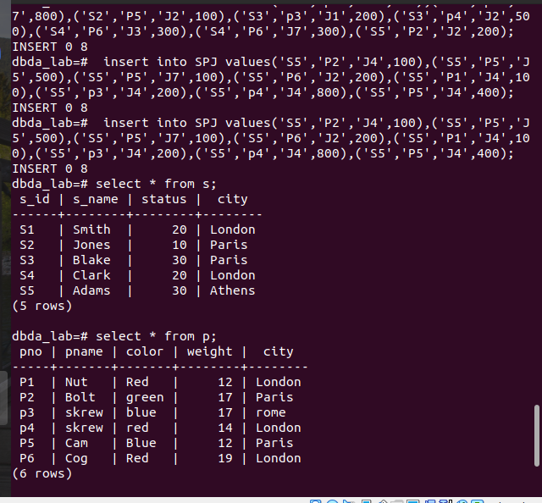

**6. Display only the S# and SNAME fields from the S table.**

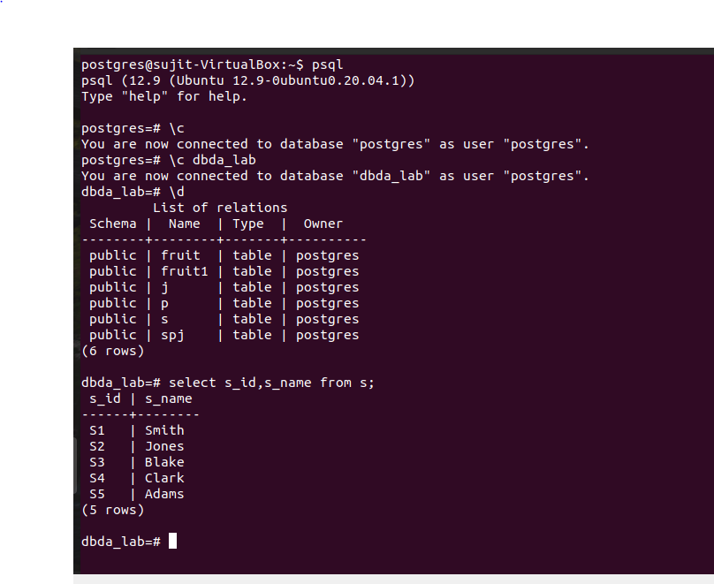

**7. Display the PNAME and COLOR from the P table for the CITY=”London”.**

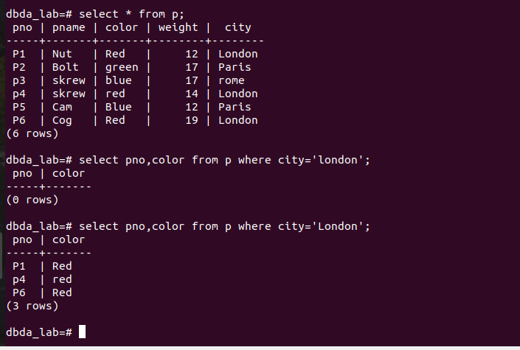

**8. Display all the Suppliers from London.**

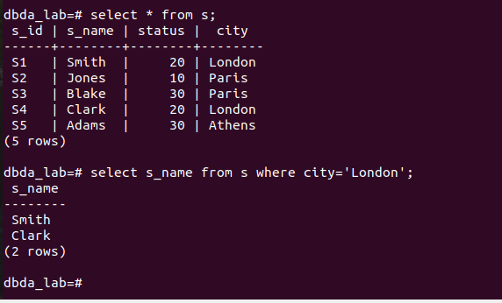

**9. Display all the Suppliers from Paris or Athens.**

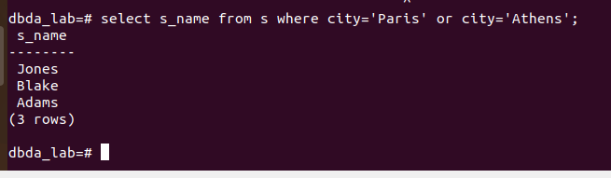

**10. Display all the Projects in Athens.**

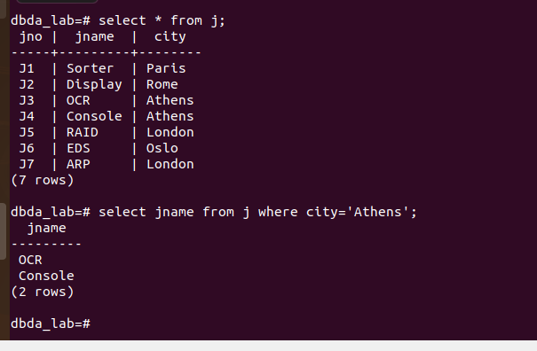

**11. Display all the Partnames with the weight between 12 and 14 (inclusive of both).**

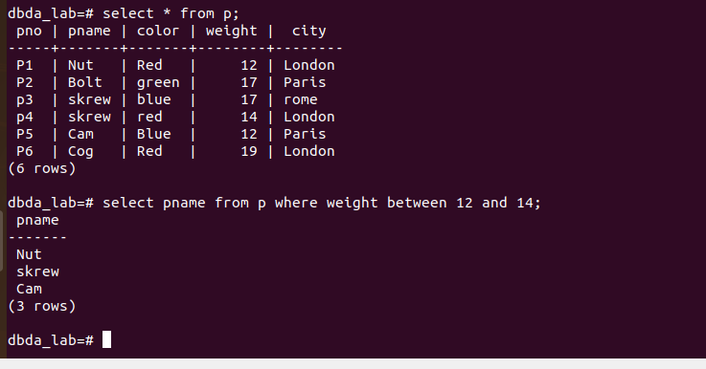**12. Display all the Suppliers with a Status greater than or equal to 20.**

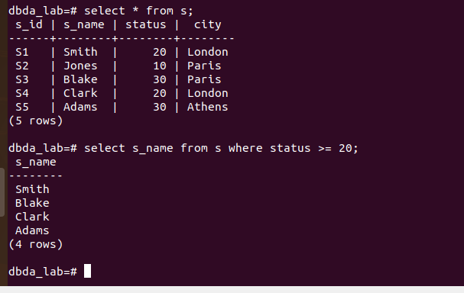

**13. Display all the Suppliers except the Suppliers from London.**

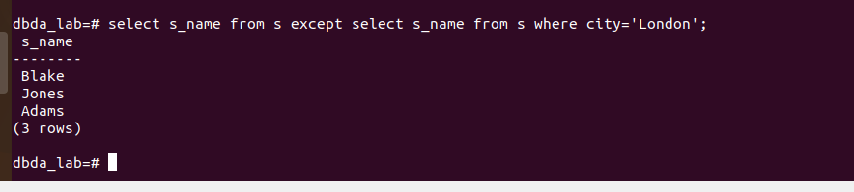

**14. Display only the Cities from where the Suppliers come from.**

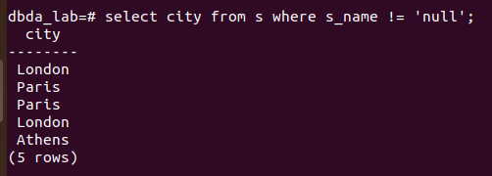

**15. Assuming that the Part Weight is in GRAMS, display the same in**